ZD
REPORT OF POST CLEAN-UP VERIFICATION AND CERTIFICATION (PCVC) EXERCISE OF NAOC IMPACTED SITE ON 4’’ OSHIE 6Ls FLOW LINE @ AKARAOLU IN AHOADA WEST L.G. AREA OF RIVERS STATE.
INTRODUCTION:
The Agency participated in a Joint Post-Clean-Up Verification and Certification exercise (letter dated 11th July, 2014) to NAOC impacted Site at Oshie 6Ls Flow Line at Akaraolu in Ahoada West Local Government Area of Rivers State, in company of representatives from NAOC, Rivers State Ministry of Environment, Akaraolu Community and EBD International Services. We were informed that the spill occurred in the year 2013 (Refer to Letter of Invitation attached) and Clean-Up was done on 15th of April 2014, as reported by the NAOC representative. Please find below, the report of the exercise.
FACILITY: NAOC
LOCATION: 4’’ Oshie 6Ls Flow Line @ Akaraolu in Ahoada West Local Government Area of Rivers State. (See Map attached)
TEAM MEMBERS:
- Koms Abam NOSDRA
- Musa Sanni Sampler
- Ihedike Olwer NAOC HSE
- Mankie Tanen B. RSMinE
- Prince Napoleon Land Lord (COMMUNITY)
- Kelechi Amadi EBD Int’L Services
SPILL DETAILS:
- INCIDENT NUMBER: 2013/LAR/254/520
- DATE OF SPILL: 29-09-2013
- COURSE OF SPILL: Sabotage
- MATERIAL SPILLED: Crude
- QUANTITY SPILLED: 35 Barrels
- QUANTITY RECOVERED: ? Barrels
- AREA IMPACTED: 1.7Ha
- DATE CLEAN-UP COMMENCED/DURATION: 4TH April 2014 (12 days)
- CLEAN-UP METHOD: No Information
- DATE OF PCI: 11-07-2014
- CONTRACTOR’S NAME: EBD International Services
- SPILL POINT COORDINATES: N 05⁰ 06’ 0.10’’
E 006⁰ 30’ 0.80’’
Please NOTE that:-
- The Clean-Up Contractor was NOT brought to Site. His representative could not answer questions relating to the clean-up process, like: - the method employed for clean-up, how the waste was disposed-of and how the impacted Site was managed. Until the Agency gets involved with the process, we will continue to rely on whatever information the Contractor or the Operator gives us.
OBSERVATION:
- There was no evidence of human activity on Site; if the clean-up was done in April 2014 as we were told by NAOC. Fresh (grasses) Vegetation has grown on the impacted area (See Fig. 1a & b)
- There was also evidence of bush burning within and around the impacted area (See Fig. 1b & c). This gives me room to suspect that the area was subjected to fire after the spill.

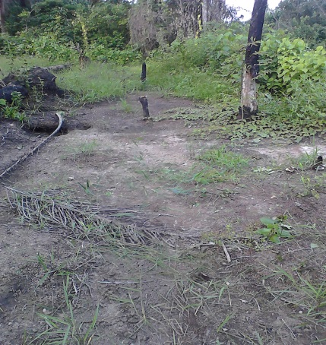 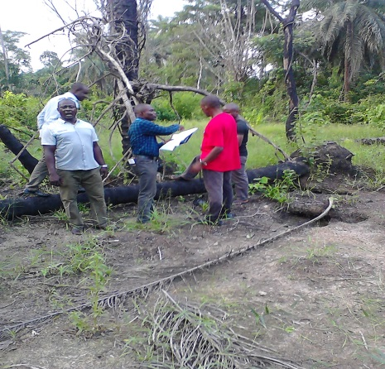 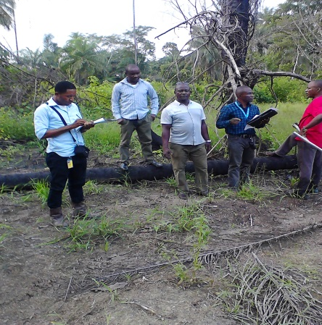 Fig. 1a Impacted Site Fig.1b Area showing burnt tress Fig. 1c Vegetation rejuvenating
SAMPLING ACTIVITY: Eleven (11) Soil Samples and One (1) Control Sample were taken at different depths (Top – Bottom; 0-15cm & 15-30cm) for analyses. The Coordinates are presented below:-
OS 1 SOIL SAMPLE 1 N 05⁰ 05’ 57.61’’
E 006⁰ 30’ 0.00’’
OS2 SOIL SAMPLE 2 N 05⁰ 05’ 57.51’’
E 006⁰ 30’ 2.14’’
OS 3 SOIL SAMPLE 3 N 05⁰ 05’ 56.68’’
E 006⁰ 30’ 1.03’’
OS 4 SOIL SAMPLE 4 N 05⁰ 05’ 59.44’’
E 006⁰ 30’ 0.06’’
OS 5 SOIL SAMPLE 5 N 05⁰ 05’ 58.42’’
E 006⁰ 29’ 9.05’’
OS 6 SOIL SAMPLE 6 N 05⁰ 05’ 58.41’’
E 006⁰ 30’ 1.14’’
OS 7 SOIL SAMPLE 7 N 05⁰ 06’ 0.49’’
E 006⁰ 30’ 1.14’’
OS 8 SOIL SAMPLE 8 N 05⁰ 05’ 58.40’’
E 006⁰ 30’ 3.19’’
OS 9 SOIL SAMPLE 9 N 05⁰ 05’ 59.49’’
E 006⁰ 30’ 2.13’’
OS 10 SOIL SAMPLE 10 N 05⁰ 06’ 0.18’’
E 006⁰ 30’ 2.89’’
SP SOIL SAMPLE SP N 05⁰ 06’ 0.10’’
E 006⁰ 30’ 0.80’’
CONTROL SOIL SAMPLE C N 05⁰ 06’ 03.4’’
E 006⁰ 30’ 02.9’’

DOCUMENTATION: Still Pictures were taken to cover the Site.

RECOMMENDATION:
- In the light of the above physical observations, documentation and data collection, the Clean-Up exercise of the impacted Site was adjudged Satisfactory. However;
- Where the Laboratory Results of the Soil Samples collected shows tolerable limits of Hydrocarbon Contents, the Site may be certified good for Close-Out.
- NOSDRA should be involved in the Clean-Up process, to avoid haven to depend on the Operator for information on the Site, since at most times the Contractor will never be brought to Site.
- The Clean-Up Contractor should also be asked to come to Site, so that questions relating to the clean-up process can be answered directly by them.
CONCLUSION:
This Report is submitted for your information and attention, while I wait for further instructions and directives.

DATE: 11th July, 2014

